City of Ruthven, Iowa
“Come for a Visit, Stay for a Lifetime!”

1305 Gowrie St.
Ruthven, IA 51358
Phone: (712) 837-5355
Fax: (712) 837-3314

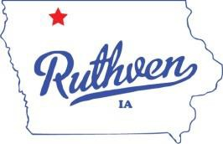Mayor
David J. Kirk

Mayor Pro Tem- Council Member Jay Schoning

Council Members Mitch Anderson Dustin Johnson Marcelle Simington Terrence Williams

City Clerk
Jessica Schneider

Deputy City Clerk
Anesa McGregor

Public Works Director David Conlon

Street Superintendent Michael Loder

City Attorney
David Stein Jr.

AGENDA
RUTHVEN CITY COUNCIL MEETING April 28, 2021 - 6:30 PM

- CONSENT AGENDA: All items listed under the consent agenda will be enacted by one motion. There will be no separate discussion of these items unless a request is made prior to the time Council votes on the motion.
  - Minutes; April 14, 2021 Council Meeting
  - Summary list of claims
  - Clerk’s reports, financials
  - Approval of Liquor license for Bully’s Bar and Grill

- WATER/SEWER/STREETS
- Approval of CDBG Draw #2 for the Waste water Treatment Plant in the amount of $4,952.

- OTHER
- Approve Fire Auxiliary to use water for fundraiser during Bully Bullhead Weekend.

- MOTION TO ADJOURN

