City of Ruthven, Iowa
“Come for a Visit, Stay for a Lifetime!”

1305 Gowrie St.
Ruthven, IA 51358
Phone: (712) 837-5355
Fax: (712) 837-3314

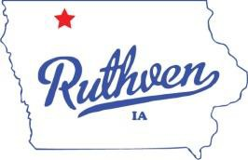
Mayor
David J. Kirk

Mayor Pro Tem- Council Member Jay Schoning

Council Members Mitch Anderson Dustin Johnson Marcelle Simington Terrence Williams

City Clerk
Jessica Schneider

Deputy City Clerk
Anesa McGregor

Public Works Director David Conlon

Street Superintendent Michael Loder

City Attorney
David Stein Jr.

AGENDA
RUTHVEN CITY COUNCIL MEETING May 26, 2021 - 6:30 PM

- CONSENT AGENDA: All items listed under the consent agenda will be enacted by one motion. There will be no separate discussion of these items unless a request is made prior to the time Council votes on the motion.
  - Minutes; May 13, 2021 Council Meeting
  - Summary list of claims
  - Clerk’s reports, financials

- PUBLIC HEARING 6:30 P.M.
- Public Hearing on the City of Ruthven Iowa’s 2020-2021 City Budget amendment
- RESOLUTION 21-2021- A Resolution Amending the Current Budget for Fiscal Year Ending June 30, 2021.

- WATER/SEWER/STREETS
  - Pool

- OTHER
- -RESOLUTION NO 22-2021 – A Resolution Temporarily Closing City Streets to Accommodate a Special Community Activity. Specifically Bible School

- MOTION TO ADJOURN

