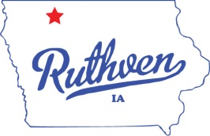 City of Ruthven, Iowa

1305 Gowrie St.

Ruthven, IA 51358

Phone: (712) 837-5355

Fax: (712) 837-3314

“Come for a Visit, Stay for a Lifetime!”

**AGENDA**

**RUTHVEN CITY COUNCIL MEETING**

**April 14, 2021 - 6:30 PM**

1. **CONSENT AGENDA:** All items listed under the consent agenda will be enacted by one motion. There will be no separate discussion of these items unless a request is made prior to the time Council votes on the motion.
   * Minutes; March 24, 2021 Council Meeting
   * Summary list of claims
   * Clerk’s reports, financials
2. **WATER/SEWER/STREETS**
   * **Approve new meter software and purchase of new meter heads.**
3. **OTHER**

* **City Wide Clean-Up Day**
* **Nuisance Properties**
* **Lifeguard/Sanitation**
* **Library Board of Trustee Vacancy**

1. **MOTION TO ADJOURN**

**Mayor**

David J. Kirk

**Mayor Pro Tem-Council Member**

Jay Schoning

**Council Members**

Mitch Anderson

Dustin Johnson

Marcelle Simington

Terrence Williams

**City Clerk**

Jessica Schneider

**Deputy City Clerk**

Anesa McGregor

**Public Works Director**

David Conlon

**Street Superintendent**

Michael Loder

**City Attorney**

David Stein Jr.